Core Concepts
- Pods and Nodes:
  - Pods run containers which require CPU and memory resources.
  - Nodes have fixed CPU and memory capacity (e.g., 4 CPUs, 4 GB memory).
  - Scheduler assigns pods to nodes based on resource availability, node selectors, tolerations, and affinity.
- Resource Requests and Limits:
  - Request: Minimum guaranteed resource allocation for a pod.
  - Limit: Maximum resource a pod can consume.
  - They are specified inside the container spec in the pod YAML.
  - Requests influence scheduling decisions; pods are only scheduled if nodes have enough requested resources available.
  - Limits prevent pods from consuming excessive resources and affecting node stability.
- Behavior without Requests and Limits:
  - A pod without specified requests and limits can consume all node resources.
  - Excess memory usage results in the pod being killed with an Out of Memory (OOM) error.
  - Excess CPU usage results in CPU throttling rather than killing the pod.
  - When a pod consumes all resources, the node becomes unavailable for other pods.
- Kubernetes Metrics Server:
  - Exposes CPU and memory usage metrics for nodes and pods.
  - Enables autoscaling mechanisms like Horizontal Pod Autoscaler (HPA) and Vertical Pod Autoscaler (VPA).

Demonstrations and Examples
Example Case | Request (Memory) | Limit (Memory) | Overridden Usage | Outcome
Pod 1 (Memory demo CTR) | 100 Mi | 200 Mi | 150 Mi | Pod runs successfully within limits
Pod 2 (Memory demo 2) | 50 Mi | 100 Mi | 250 Mi | Pod is OOM killed (exceeds limit)
Pod 3 (Memory demo 3) | 1000 Gi | 1000 Gi | 150 Mi | Pod stuck in Pending state (insufficient node memory)
- The stress testing pod uses the Linux stress tool to simulate memory pressure.
- Requests and limits are crucial to prevent a single pod from starving the node of resources.
- If a pod tries to consume more than its limit, Kubernetes kills it (OOM kill), protecting the node.
- If requested resources exceed node capacity, the pod remains unscheduled until resources free up or requests are lowered.

Key Insights
- Resource requests define the minimum resources guaranteed to a pod, affecting scheduling decisions.
- Resource limits cap the maximum resources a pod can consume, preventing node instability.
- Without requests and limits, pods can cause resource contention leading to pod crashes or node instability.
- Kubernetes prefers to kill the pod exceeding limits rather than letting the node crash.
- The metrics server is essential for monitoring resource usage and enabling autoscaling features.
- Namespace specification in YAML files ensures resources are created in the intended namespace.

Best Practices Highlighted
- Always specify both requests and limits for CPU and memory in pod specs.
- Use metrics server to monitor cluster resource utilization.
- Properly set requests and limits based on workload characteristics to maintain cluster stability.
- Adjust requests and limits to ensure pods can be scheduled and run reliably.
- Utilize stress testing to simulate real-world resource usage patterns.

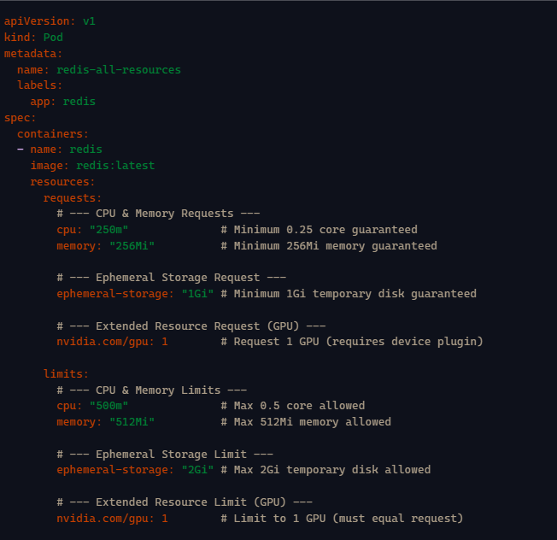
CPU & Memory: Requests guarantee scheduling; limits cap usage.
- Ephemeral Storage: Controls /tmp and writable layer usage.
- GPU (extended resource): Must request and limit equally; GPUs aren’t shareable.
- Requests vs Limits:
- Requests = minimum guaranteed.
- Limits = maximum allowed.

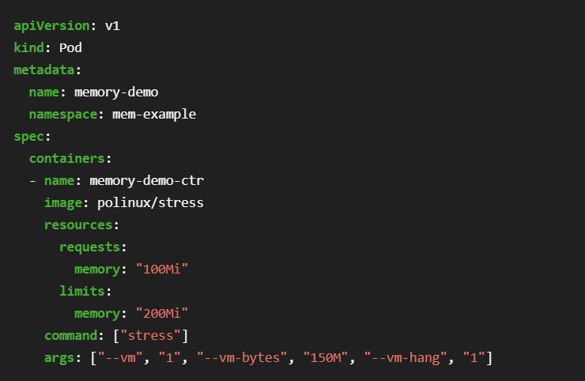
The args section in the configuration file provides arguments for the Container when it starts. The "--vm-bytes", "150M" arguments tell the Container to attempt to allocate 150 MiB of memory.

Create the Pod:

kubectl apply -f https://k8s.io/examples/pods/resource/memory-request-limit.yaml --namespace=mem-example

